**_________________________________________________________**

**_________________________________________________________**

**_________________________________________________________**

**_________________________________________________________**

**___________________________________________________[marking notes]**

**CP5046** ASSESSMENT TASK 3: **Project Audit**

This assessment task has been prepared by Dr. Dmitry Konovalov for James Cook University. Updated 15 February 2018.

**© Copyright 2015**

This publication is copyright. Apart from any fair dealing for the purpose of private study, research, criticism, or review as permitted under the Copyright Act, no part may be reproduced by any process or placed in computer memory without written permission.

|  |  |
| --- | --- |
| Aligned MIT course & CP5046 subject learning outcomes | * SLO - Subject Learning Outcome: SLO-1, SLO-2, SLO-3, SLO-5; * MLO - MIT Course Learning Outcome : MLO-K1, MLO-K2, MLO-S4, MLO-S5, MLO-A1, MLO-A3. |
| **Group or individual** | *Individual.* ***Students from the same team may be awarded different marks for this assessment item*** |
| **Weighting / Length** | *50%* |
| **Due date** | *before the last workshop* |

## ASSESSMENT TASK DESCRIPTION

This task is the Audit of: (i) your group ICT solution delivered to the client, and (ii) ***individual contributions*** to the overall team effort and results. In terms of the Agile Software development, this is the ***iteration-2***. It delivers the ***alpha release*** to the client, and makes planning for ***iteration-3*** (***beta release***), which is due middle of CP3047/CP5047.

## [Total awarded _____ out of 100 marks] ASSESSMENT TASK CRITERIA SHEET

***NOTE! Students from the same team may be awarded different marks for this assessment item. To arrive at the individual student marks, your lecturer may consider all or some of the following contributing factors: your team overall marks; team feedback forms; personal observations of the student project contribution; student workshop attendance and subject participation; student competency during workshops, this audit and the project presentation.***

The following is the list of items which are required to be completed in this assignment. Maximum possible marks are given in brackets at the beginning of each item. Where relevant, the SLOs and BLO/MLOs from the preceding table are specified.

**[____/Prerequisite for marking]** Assignment is completed using electronic copy of ***this*** document and submitted to LearnJCU electronically.One submission per team.

**[_____/20 marks, BLO-S5] *Individual* Team Feedback form is submitted to LearnJCU electronically.** One submission per student. Assignment is done in a group with 2-4 students.

Write group members here:

Student Name-1, Project role(s), specific ***individual*** contributions to each of the assessment items (Documentation, Presentation, Audit):

Student Name-2: ...

Note: Each student ***must be present*** at the audit, and must be ready to answer any questions regarding the student’s individual contribution.

**[_____/40 marks, SLO-1, SLO-2, BLO-S3] Report and demonstrate the *ACTUALLY* delivered alpha-release (see your user stories in iteration-1).** Any deviations from the alpha-release-iteration-1 must be documented and briefly explained. Screen-shots (or illustrations) of running alpha-release with comments or explanations.Write here: Minimum **TWO** pages, maximum **TEN** pages.

**[_____/20 marks, BLO-K1, BLO-K3, BLO-S5, MLO-K1, MLO-S5] Client signed acceptance of the alpha-release, and the proposed beta- and final-releases**. Any changes from iteration-1 are approved by the client. Write here: Minimum **TWO** pages, maximum **TEN** pages.

* [____/5 marks] Provide the burn-down and velocity charts/values for iteration-2, and how they are used to plan beta- and final-releases.

**[_____/20 marks, SLO-1, SLO-2, SLO-3, BLO-K1, BLO-S3, MLO-K1, MLO-S4, MLO-S5] Demonstrate the Project development and release ICT infrastructure.** This must include development environment, programming languages, source code repositories (Configuration Management), project collaboration tools, and development tools. Write here: minimum **TWO** pages, maximum **TEN** pages.

* [___/10 marks] **Configuration Management**/version control, e.g. git, github, heroku, bitbucket; Project tools. Programming languages/IDEs. Building tools/procedures. How to set-up your development/release environment for a new team member.
* [___/10 marks] **Prototypes are demonstrated to justify the proposed beta-release**.

**Marking Rubric for Project Audit:** This assessment rubric provides you with the characteristics of exemplary, competent, marginal and unacceptable work in relation to task criteria.

|  |  |  |  |  |
| --- | --- | --- | --- | --- |
| **Criteria** | **Exemplary (DISTINCTION-level)** | **Competent (CREDIT-level)** | **Marginal (PASS-level)** | **Unacceptable (FAILED-level)** |
| **Individual Team Feedback form is submitted to LearnJCU electronically. Assignment is done in a group with 2-4 students.** | **20**  Group demonstrated **exemplary ability** to work collaboratively, e.g. all team members always attended the same workshop. Feedback is objective to other members and for self-improvement | **15** Group demonstrated **competent ability** to work collaboratively, e.g. all team members nearly always attended the same workshop.Feedback is fair to other members and for self-improvement | **10**  Group demonstrated **marginal ability** to work collaboratively, e.g. all team members sometimes attended the same workshop. Feedback is not objective to other members and/or does not identify any area for self-improvement | **0**  Group did not demonstrated ability to work collaboratively. |
| **Report and demonstrate the ACTUALLY delivered alpha-release** | **40**  All delivered user stories are correct, correctly implemented, and tested. Technical information in the report is exemplarily. High quality presentation and formatting of the report. Delivered alpha-release is as per iteration-1 planning. | **30** Minor errors in: All delivered user stories are correct, correctly implemented, and tested. Technical information in the report is competent. | **20** More than half of delivered user stories are correct, correctly implemented, and tested. Technical information in the report is PASS-level. | **0**  Not done, or done unacceptably. |
| **Client signed acceptance of the alpha-release, and the proposed beta- and final-releases** | **20**  Clear evidence of client’s acceptance and running of the alpha-release. Clear and meaningful feedback on the alpha-release. Signed plans for beta- and final releases. And all user stories are correct, and correctly estimated | **15** Some evidence of client’s acceptance, and/or client is NOT running alpha-release. Signed plans for beta- and final releases. Or most user stories are correct, and correctly estimated | **10**  Minimal evidence of client’s acceptance, or client is NOT running alpha-release. Signed plans for beta- and final releases. Or more than half of user stories are correct, and correctly estimated | **0**  Not done, or done unacceptably.  No signed plans for beta- and final releases. Or less than half of user stories are correct, and correctly estimated |
| **Demonstrate the Project development and release ICT infrastructure** | **20**  Description very clearly communicates exemplary ICT solutions. | **15** Description clearly communicates competent ICT solutions. | **10**  Description communicates ICT solutions. | **0**  Not done, or done unacceptably. |

## Reference BIT & MIT course and learning outcomes

|  |  |
| --- | --- |
| MIT course & CP5046 subject learning outcomes | * SLO-1 - Communicate technical information clearly through presentations, demonstrations and documentation; * SLO-2 - Choose and apply the appropriate agile methodologies; * SLO-3 - Evaluate and select appropriate tools and technologies to meet project requirements * SLO-4 - Develop a general knowledge of industry standard project management approaches; * SLO-5 - Critically reflect on progress to tailor self learning goals to advance professional development; * MLO-K1 - Critically analyse to select appropriate tools and technologies to meet project requirements; * MLO-K2 - Evaluate industry standard contexts for project management approaches; * MLO-S4 - Apply lateral and original thinking to conceptualise and evaluate a range of solutions to relevant problems; * MLO-S5 - Communicate technical information clearly through presentations, demonstrations and documentation; * MLO-A1 - Apply appropriate tools and technologies to meet project managements; * MLO-A3 - Critically reflect on progress to tailor self-learning goals to advance professional development. |

**CP5046** ASSESSMENT TASK 3: **Project Audit**

1.Team contribution

Team member:

|  |  |
| --- | --- |
| Rui Zhao | Homepage,Picture gallery function, modify the final release |
| Yuxing Qian | Navigation bar |
| Rajat khajuria | Response size,modify the final release |

Homepage

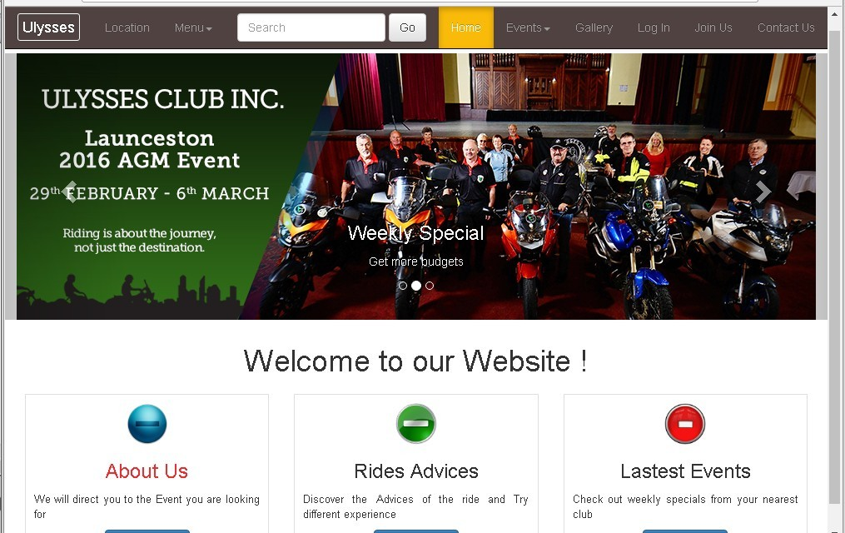

1. **Bootstrap**

**<!doctype html>**

**<html>**

**<head>**

**<meta charset="utf-8">**

**<meta http-equiv="X-UA-compatible" content="IE=edge">**

**<meta name="viewport" content="width=device-width, initial-scale=1">**

**<!-- Latest compiled and minified CSS -->**

**<link rel="stylesheet" href="https://maxcdn.bootstrapcdn.com/bootstrap/3.3.7/css/bootstrap.min.css" integrity="sha384-BVYiiSIFeK1dGmJRAkycuHAHRg32OmUcww7on3RYdg4Va+PmSTsz/K68vbdEjh4u" crossorigin="anonymous">**

1. **Navigation Bar**

**<title>BRAND</title>**

**</head>**

**<body style="padding-top: 70px">**

**<nav class="navbar navbar-default navbar-fixed-top navbar-inverse">**

**<div class="container-fluid">**

**<!-- Brand and toggle get grouped for better mobile display -->**

**<div class="navbar-header">**

**<button type="button" class="navbar-toggle collapsed" data-toggle="collapse" data-target="#topFixedNavbar1"><span class="sr-only">Toggle navigation</span><span class="icon-bar"></span><span class="icon-bar"></span><span class="icon-bar"></span></button>**

**<a class="navbar-brand" href="#"><span class="title">Ulysses</span></a></div>**

**<!-- Collect the nav links, forms, and other content for toggling -->**

**<div class="collapse navbar-collapse" id="topFixedNavbar1">**

**<ul class="nav navbar-nav">**

**<li><a href="#">Location</a></li>**

**<li class="dropdown"><a href="#" class="dropdown-toggle" data-toggle="dropdown" role="button" aria-expanded="false">Menu<span class="caret"></span></a>**

**<ul class="dropdown-menu" role="menu">**

**<li><a href="#">Promotion</a></li>**

**<li><a href="#">Coupons</a></li>**

**<li><a href="#">Suppliers</a></li>**

**<li class="divider"></li>**

**<li><a href="#">Subcrib</a></li>**

**<li class="divider"></li>**

**<li><a href="#">Feedback</a></li>**

**</ul>**

**</li>**

**</ul>**

1. **Search bar function**

**<form class="navbar-form navbar-left" role="search">**

**<div class="form-group">**

**<input type="text" class="form-control" placeholder="Search">**

**</div>**

**<button type="submit" class="btn btn-default">Go</button>**

**</form>**

**<ul class="nav navbar-nav navbar-right">**

**<li class="active"><a href="#">Home<span class="sr-only">(current)</span></a></li>**

1. **Scroll down menu**

**<li class="dropdown"><a href="#" class="dropdown-toggle" data-toggle="dropdown" role="button" aria-expanded="false">Events<span class="caret"></span></a>**

**<ul class="dropdown-menu" role="menu">**

**<li><a href="#">New Events</a></li>**

**<li><a href="#">Special Events</a></li>**

**<li><a href="#">Family Events</a></li>**

**<li class="divider"></li>**

**<li><a href="#"></a></li>**

**</ul>**

**</li>**

**<li><a href="#">Gallery</a></li>**

**<li><a href="#">Log In</a></li>**

**<li><a href="#">Join Us</a></li>**

**<li><a href="#">Contact Us</a></li>**

**</ul>**

**</div>**

**<!-- /.navbar-collapse -->**

1. **Response size function**

<!-- Optional theme -->

<link rel="stylesheet" href="https://maxcdn.bootstrapcdn.com/bootstrap/3.3.7/css/bootstrap-theme.min.css" integrity="sha384-rHyoN1iRsVXV4nD0JutlnGaslCJuC7uwjduW9SVrLvRYooPp2bWYgmgJQIXwl/Sp" crossorigin="anonymous">

<link href="file:///E|/5310 Presentation/Presentation.new/css/style.css" rel="stylesheet" type="text/css">

<!--[if lt IE 9]>

<script src="https://oss.maxcdn.com/html5shiv/3.7.3/html5shiv.min.js"></script>

<script src="https://oss.maxcdn.com/respond/1.4.2/respond.min.js"></script>

<![endif]-->

**Style.Css**

@charset "utf-8";

/* CSS Document */

.navbar.navbar-default.navbar-fixed-top.navbar-inverse {

background:#514242;

}

.title {

color:#fff;

border:1px solid #fff;

padding:5px;

border-radius:3px;

}

.dropdown ul li a:hover {

background:#b9fcf9;

}

.nav navbar-nav navbar-right li a:focus {

background:#12bfe3;

}

.nav navbar-nav navbar-right li a:focus {

background:#fff;

}

.navbar-inverse .navbar-nav>.active>a,.navbar-inverse .navbar-nav>.active>a:focus,.navbar-inverse .navbar-nav>.active>a:hover{

background:#FaBA0A;

}

.heading {

text-align:center;

padding:10px 0;

}

.img-circle {

width:50px;

}

.call-to-action {

border:1px solid #DFDFDF;

padding:10px;

}

.one {

color:#F4292C;

}

.Two {

color:#2E0C0c;

}

.Thress {

color:#20450c;

}

.height {

text-align:justify;

font-size:13px;

padding-bottom:10 px;

}

@media screen and (max-width:320px) {

.carousel-caption h3{

display:none;

}

}

@media screen and (min-width:321px) and (max-width:360px){

.carousel-caption h3{

font-size:18px;

}

}

Burn down chart

|  |  |  |
| --- | --- | --- |
|  | Remaining time available | Remaining actual time |
| Beginning | 25 | 25 |
| End of week 2 | 19 | 20 |
| End of week 3 | 13 | 14 |
| End of week 4 | 7 | 8 |
| End of week 5 | 0 | 0 |

Improvement of the alpha-release and final-releases

1. alpha-release

Title: Register page

Description: modify the register page based on the requitement of the client, and implement the website to be efficient.

- The correct form of address is important for the client. The original ‘address’ box is not suitable for the users, they might type informal addresses. The ‘address’ should be divided into meaningful contents. That can help the users to type correct information.

- remove nationality, combine Home phone and Preferred contact, adjust feedback, add content to ask users the relevant time of contacting, add gender option

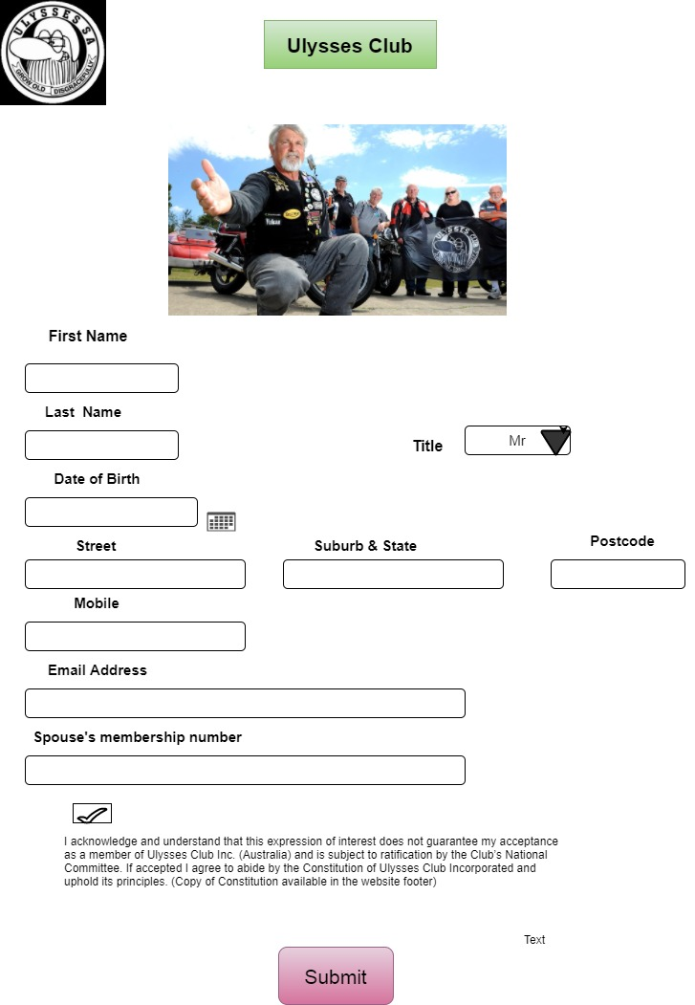

Title: homepage

Description: modify the home page based on the requitement of the client.

- The page information will be displayed in About us

- Add the Rider calendar, social news into the main site on webpage.

- Modify login/join option to remove login option which is not provided properly on the homepage.

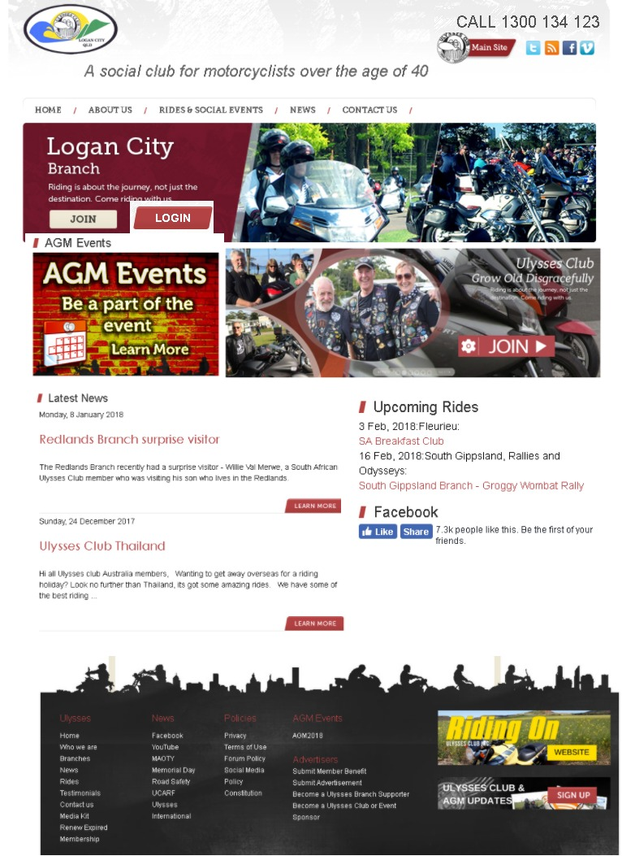

Title: Navigation bars

Description: modify the Navigation bars based on the requitement of the client.

- Add gallery option in the navigation bar.

-Add more content on NEWS navigation bar.

- Provide with the working time of the club and add more relevant contact information in CONTACT US

2. Final release

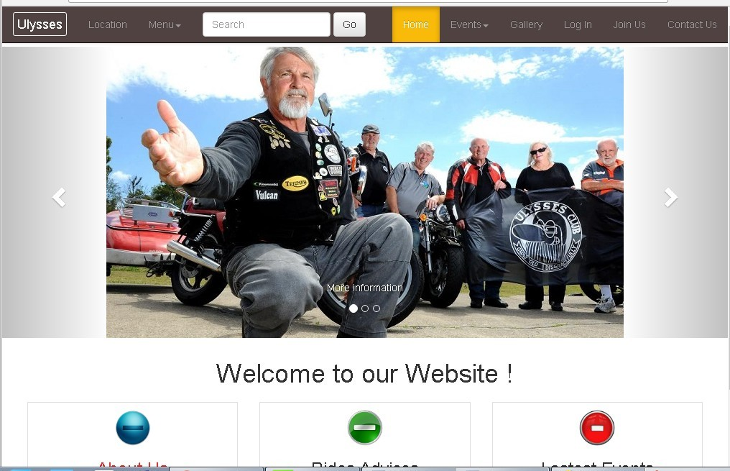

Demonstrate the Project development and release ICT infrastructure.

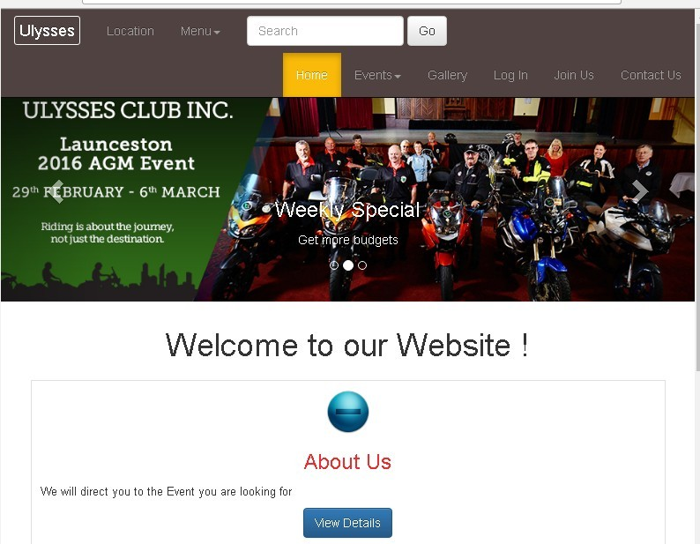

Finally, we not only modify the structure of the web page, but also design a range of new site and features base on the current web page, such as gallery site, location site, search bar, log in site and three main function windows, for example about us, ride advices and latest events.

In addition, we design a response size function for the new home page, it would be fit in multiple devices which include smart phone, pad and computer.

Last but not the least, our client’s feedback is we should consider a dynamic way in terms of the sign in form, user would complete the question on each page under the guideline, not just put all information in one page. We also agree it should be more effective and attractive for most people who are interested in Ulysses Club.

Configuration Management

We use dreamweaver for web design. Users of Dream Weaver have the ability to select different views when creating web pages. A 'code view' shows only the html code for the page. A 'design view' gives an indication of how the html page will appear in a browser. 'A split view', as the name implies, allows you to see the code view and design view at the same time. Both views are updated automatically as changes are being made and the user can immediately see the effect of any changes.

 Using GitHub is free if project is open source and issue tracker that makes it easy to include more in-depth documentation and get feedback about project. If we want to contribute, you just fork a project, make our changes and then send them a pull request using GitHub web interface.